# ABC’s Inventory Management System

## Log In Test Script

|  |  |  |  |  |  |
| --- | --- | --- | --- | --- | --- |
| **Test Name** | | Test Login Function | | | |
| **Use Case Tested** | | Log In/ Out | | | |
| **Test Description** | | This test tests if the system can log in with username and password | | | |
| **Pre-Conditions** | | Meta data must exist, users sign in details like username, password must exist. | | | |
| **Post-Conditions** | | If the username and password is correct, system will direct user to the home page interface.  If the username and password is incorrect, system will alert an appropriate message and user is required to input username and password gain. | | | |
| **Notes** | | This test assumes that the user knows the username and password exists. | | | |
| **Result (Pass/Fail/Warning/ Incomplete)** | | Pass | | | |
|  | **Test Step** | | **Expected Test Results** | **P** | **F** |
| 1. | Open the ABCInventoryClient.exe file | | ABCInventoryClient system launches. | P |  |
| 2. | Type in the existing username and password that is known by the user. | | System waits for the user to hit enter or click on the ‘Log In button. | P |  |
| 3. | Hit enter or click on the ‘Log In button. | | Username with matching username and password is displayed with all other functionality base on the staff role. | P |  |

|  |  |  |
| --- | --- | --- |
| **Test Data Table** | | |
|  | **Username** | **Password** |
| **1** | n/a | n/a |
| **2** | student | student |
| **3** | hanh | Student |
| **4** | Hanh | hanh |

# Result Screenshots

The screenshots of the result on each test step for each data set are given below:

## Data Set 1

**Step 1**

User launches the ABC Inventory Management System and does not input any values and hit ‘Log In’ button.

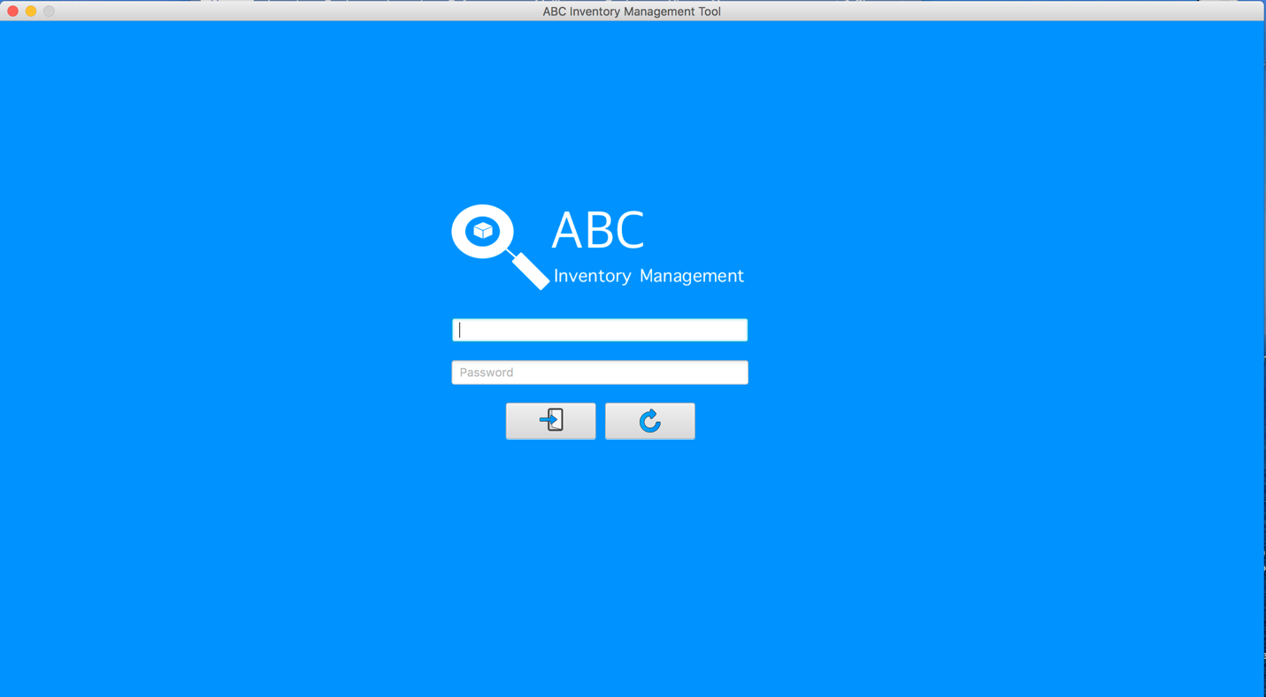

**Step 2**

An alert message is displayed to notify user should enter the username and password.

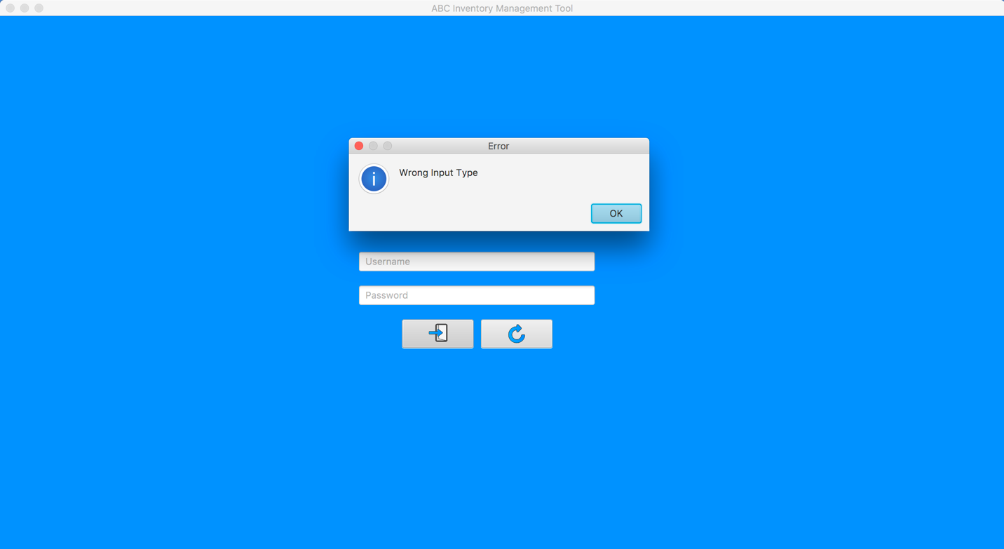

## Data Set 2

**Step 1**

User launches the ABC Inventory Management System



**Step 2**

User enter the username and password which do not exist in the system

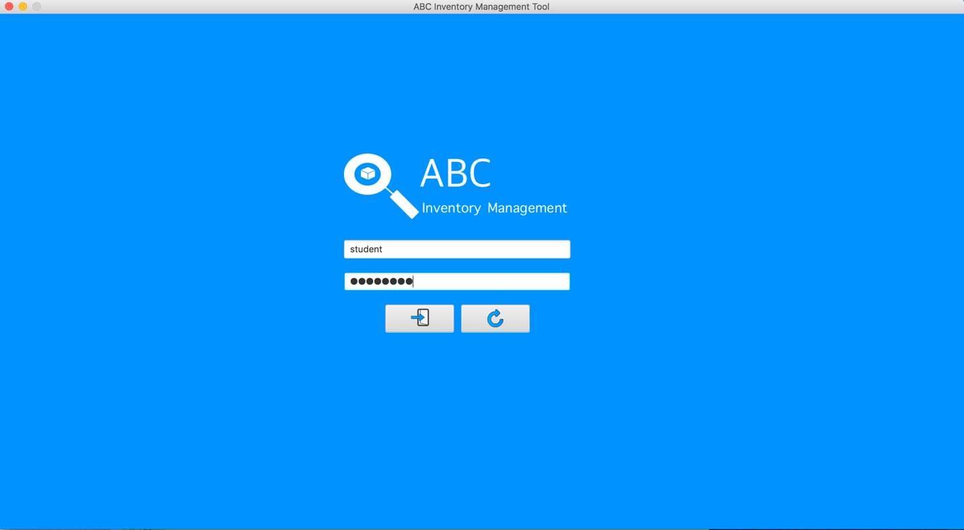

**Step 3**

An alert message is displayed to notify user entered a wrong username or password.

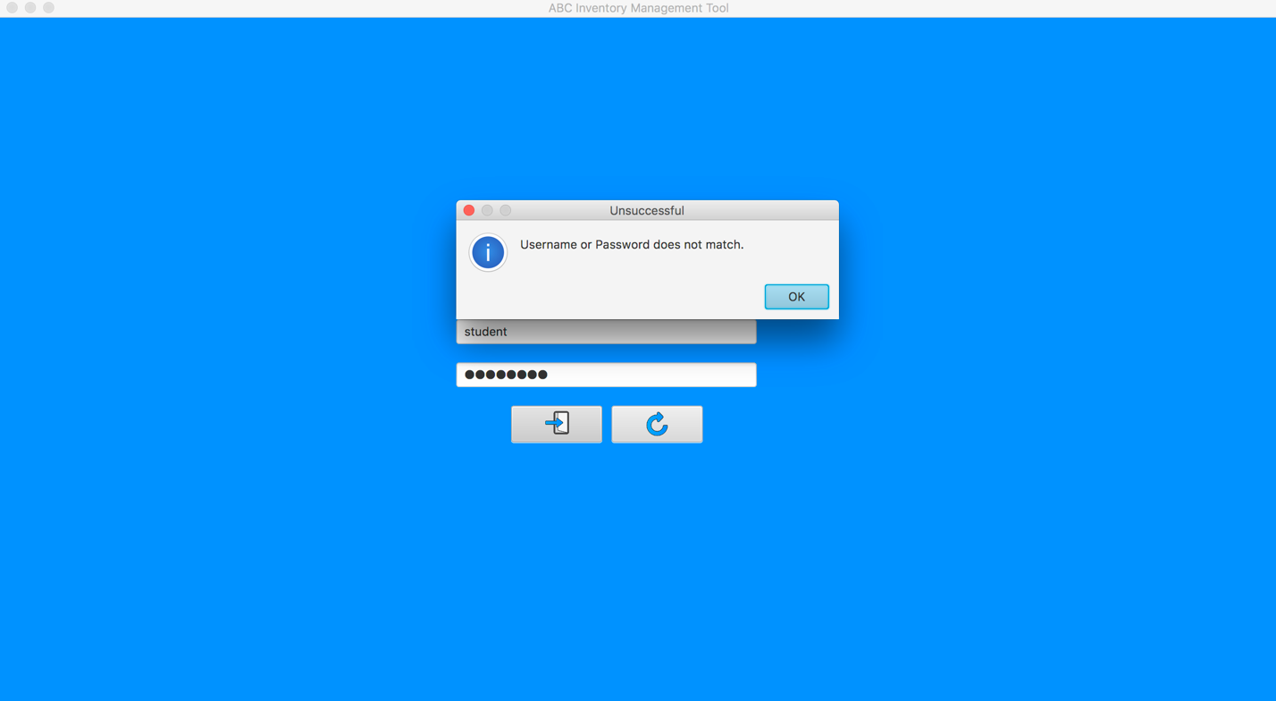

## Data Set 3

**Step 1**

User launches the ABC Inventory Management System



**Step 2**

User enter the incorrect password

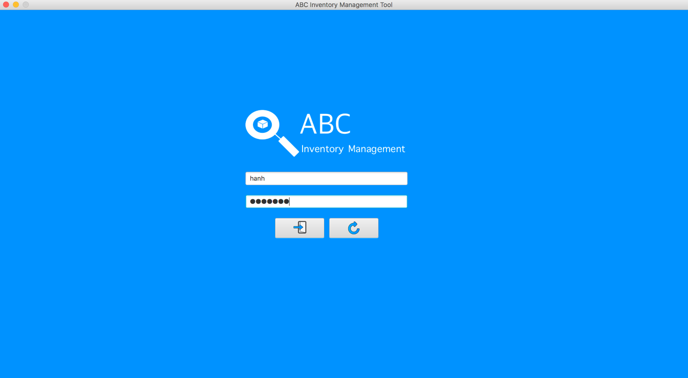

**Step 3**

An alert message is displayed to notify user entered a wrong username or password.

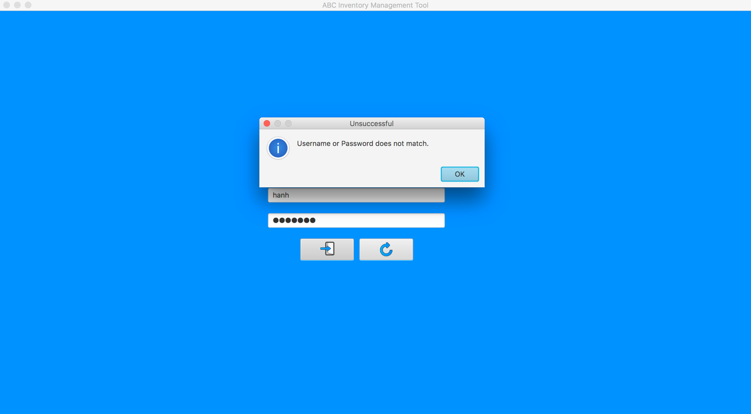

## Data Set 4

**Step 1**

User launches the ABC Inventory Management System



**Step 2**

User enter the correct username and password



**Step 3**

System direct to the homage which contains the main function

